**Research Question**

How does a change in weather affect sales of different businesses in Australia (retail, food, e-commerce, etc)?

This research question mainly focuses on sustainability as it aims to investigate the effect of weather change on sales and hence consumption of goods in Australia. Since the world’s temperature is changing, looking at these trends show us the industries that will thrive in the future in certain temperatures. Furthermore, this research question also shows us the effect of different seasons on different industries/goods.

**Importance of Research Question**

According to climate.gov, global surface temperature in 2020 is 0.5°C warmer than the average in 1986-2005. Through the diagram below, it can be seen that the world’s temperature is moving in an upward trend.

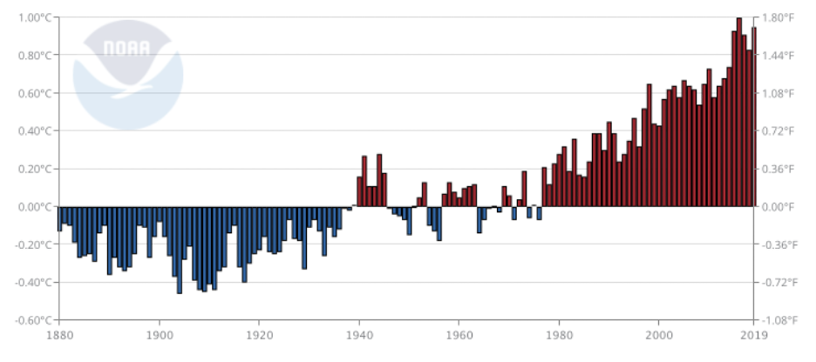

(climate.gov, 2021)

With this investigation, the research question solves businesses’ point of view, where we will identify whether there is a specific industry that thrives with increasing temperature. The research question allows future planning and preparation for businesses who supply these goods in the future as demand might be predicted to increase.

This investigation would interest a lot of stakeholders in the business side, including business owners, investors, government tax officers, and activists. Owners and investors would be able to use the data to predict goods or industries that have the potential to thrive with increasing temperature. Tax officers and activists would potentially be able to use the analysis to get a conclusion whether specific goods that are causing increasing climate change are consumed more with higher temperature (positive correlation between harmful goods and temperature). Then, tax officers and activists could get data to try to either tax or encourage people in alternative goods.

**Datasets**

Data for weather:

http://www.bom.gov.au/climate/data/

http://www.bom.gov.au/climate/averages/tables/cw_086071.shtml

This is in the form of .csv containing data from weather stations in different cities from 2013. This contains mean maximum temperature and mean minimum temperature.

Data for sales:

https://www.abs.gov.au/statistics/industry/retail-and-wholesale-trade/retail-trade-australia/latest-release#data-download

This is in the form of .xls containing data for different industry per month from April 1982. The industries include food retailing, household retailing, clothing, department stores, etc.

They are linked together as they have statistics on months, which can be compared to find any trends between sales of industries and temperature.

**Methodologies**

**Merging:**

Merging of the two datasets would be needed as they are both data categorised by months.

**Group by:**

Grouping by year or total could also be needed after merging which will result in an aggregated data that can be used for an overall analysis.

**Output/Product**

The output of the product will be in the form of several graphs, showing changes of weather aggregated by month, year, and seasonal changes. This will show whether there is significant trends or correlation between increasing/decreasing temperature with sales in different industries.

**Challenges and Risks**

There are many external factors which might alter the results. Since this is measuring weather changes through many years on sales, many external factors have changed through the years. This includes growth of industry, pollution, taxation, natural disasters, etc.

There is also lack of data for weather as it only has data from 2013-2021, while the data for sales ranges from 1982-2021.